Pizza

Personal 12” Bar Pie Toppings: Sausage, Pepperoni, Bacon, Peppers, Onions, Mushrooms, Hot Peppers, Extra Cheese (1 per topping)
Plain Pizza 9.50
Meat Lovers Pizza 11.50
Sausage, Pepperoni, Bacon
BBQ Chicken Pizza 11.50
Grilled Chicken, Mozzarella, Cheddar, Sauteed Onions, BBQ Sauce

Tomato & Basil Pizza 10.50
Fresh Tomatoes, Basil, Onions, Mozzarella

Buffalo Chicken Pizza 11.50
Grilled Chicken, Mozzarella, Ranch, Buffalo Sauce
Wraps
Served with Otto’s Homemade Chips
Sub French Fries…add 1 Sub Caesar Salad or House Salad…add 2
Sub Sweet Potato Fries or Onion Rings…add 2
Chicken Bacon Ranch Wrap 11.50

Fresh Mozzarella Wrap 12.00

Chicken Caesar Wrap 11.50

T’s Wrap 12.00

Buffalo Chicken Wrap 11.50

Greek Wrap 11.50

Gumby Wrap 12.00

Sign up to become an
Otto’s VIP Member
at ottosbar.com

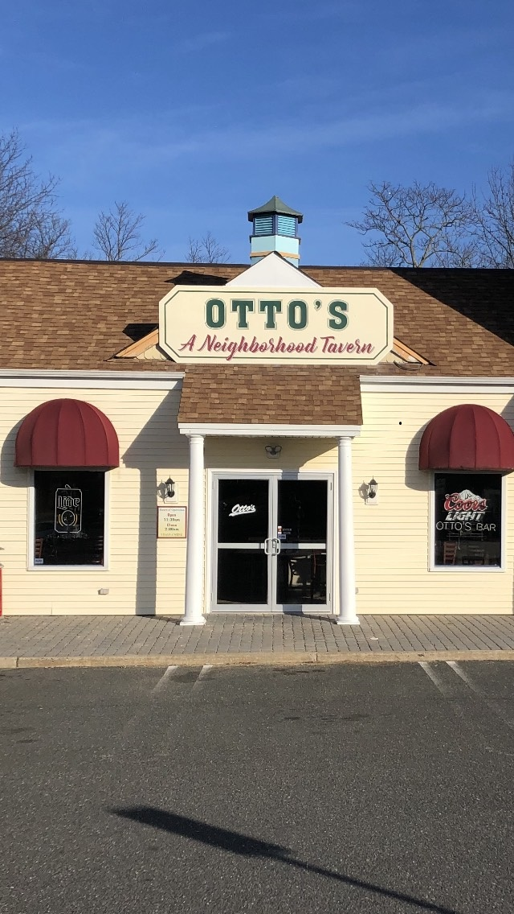

Party Section Available
-Full Hot Buffet
-Beverage Packages
-Reserved Section of the Bar
Book your next party with Us!
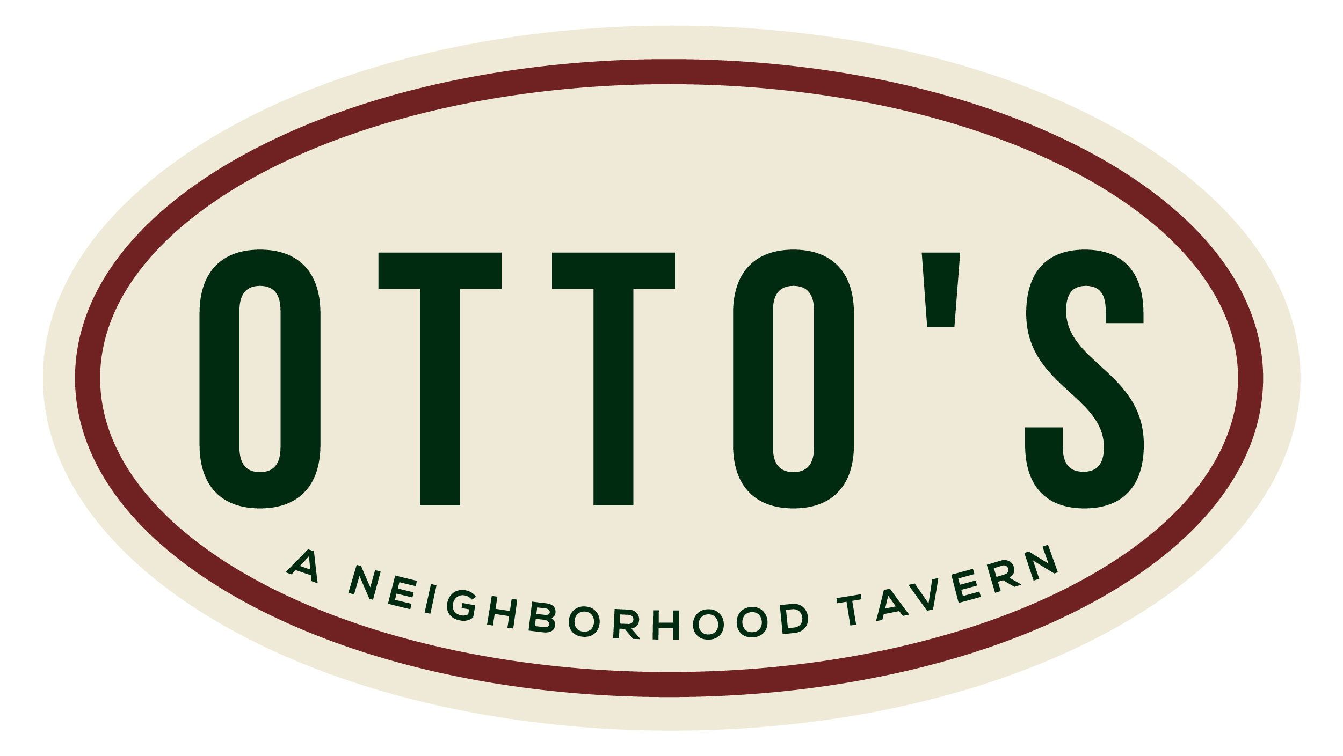



845 West Park Avenue
Ocean, NJ 07712
732-686-9566
Ottosbar.com

Appetizers

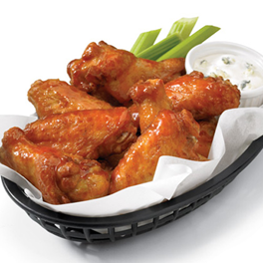
Wings Sm. 7.50 Md. 13.00 Lg. 16.50

Pretzel Bites 10.00

Chicken Quesadilla 10.50

Buffalo Chicken Dip 10.50

Grilled Cheese Bites 10.00

Jalapeno Poppers 8.50

Chicken Tenders 9.50

Mozzarella Sticks 8.00

Onion Rings 8.00

Team Platter 16.00

Zucchini Sticks 9.50

Potato Skins 9.50

Hummus Platter 11.00

Neat Nachos 10.50

Homemade Chips 6.00

French Fries 6.00

Sweet Potato Fries 8.00
Go to ottosbar.com
For menu descriptions.
Soups & Salad

French Onion 6.00

Homemade Chili 6.00

Caesar Salad 9.00

Greek Salad 10.25

T’s Salad 10.25

House Salad 9.00

JB’s Salad (comes with chicken) 13.00

{Add Chicken to any salad for 3}

Sandwiches

Served with Otto’s Homemade Chips
Sub French Fries…add 1 Sub Caesar Salad or House Salad…add 2
Sub Sweet Potato Fries or Onion Rings…add 2
Italian Chicken Sandwich 12.50
Classic BLT Sandwich 8.50
Grilled Cheese 7.50
Pork Roll Sandwich 8.50
Grilled Chicken Sandwich 10.50
Sausage Sandwich 10.50
Poor Man’s Chicken Parm. 11.50
Shickhaus Hot Dog 8.50
Burgers
Served with Otto’s Homemade Chips
Sub French Fries…add 1 Sub Caesar Salad or House Salad…add 2
Sub Sweet Potato Fries or Onion Rings…add 2
Can Sub Veggie Burger at No Charge

Classic Burger 11.50
Jersey Burger 13.50
Black & Blue Burger 12.50
Mushroom Swiss Burger 13.50
Western Burger 13.50
Red Hot Burger 13.50

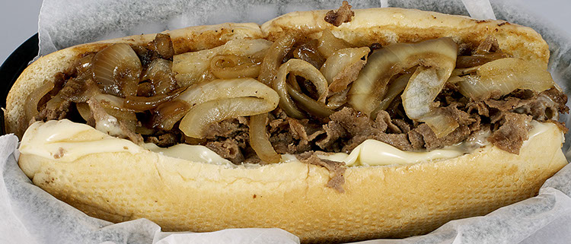
Cheese Steaks
Served with Otto’s Homemade Chips
Sub French Fries…add 1 Sub Caesar Salad or House Salad…add 2
Sub Sweet Potato Fries or Onion Rings…add 2

Philly Cheese Steak 12.00
California Cheese Steak 12.00
Red Hot Cheese Steak 12.00
Pizza Cheese Steak 12.00
Chicken Cheese Steak 12.00
Buffalo Cheese Steak 12.00

