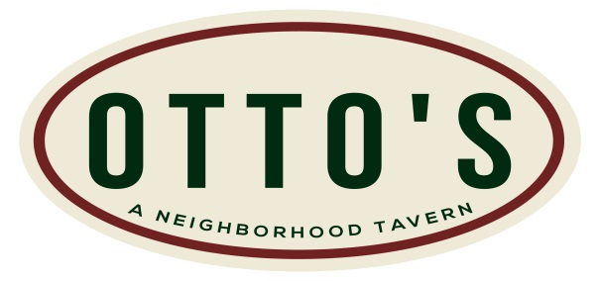
845 West Park Avenue – Ocean, NJ 732-686-9566 Let Us - Help You - Help Others!
- Four Packages to Choose From –
Package A: Cost $15 per person (Charge whatever you want and keep the difference) Includes: Appetizers, Soft Drinks, Tax & Tip. Choose four appetizers that will be served family style and splashed around the room.
Package B: Cost $20 per person (Charge whatever you want and keep the difference) Includes: One Salad Choice, Three Entrée Choices, Soft Drinks, Tax & Tip. A full buffet dinner served in chafing dishes.
Package C: Cost $30 per person (Charge whatever you want and keep the difference) Includes: One Salad Choice, Two Appetizers, Three Entrée Choices, Soft Drinks, Tax & Tip. Appetizers splashed around the room and a full buffet dinner served in chafing dishes.
Package D: Cost $40 per person (Charge whatever you want and keep the difference) Includes: One Salad Choice, Two Appetizers, Three Entrée Choices, Two Alcoholic Drinks, Soft Drinks, Tax & Tip. Appetizers splashed around the room and a full buffet dinner served in chafing dishes. Also includes two drink tickets good for any beer, wine or liquor drink. Top shelf excluded.
*Groups of 30 to 60 People *Your group can do a raffle or ask for donations in your designated area! *This is only for nonprofit organizations, teams, clubs, etc…

